33.59: a) The maximum intensity from the table is at 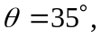 so the polarized component of the wave is in that direction (or else we would not have maximum intensity at that angle).
b) At 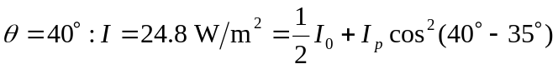
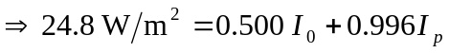 (1).
At 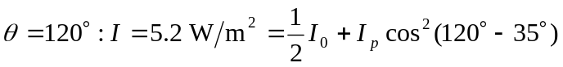
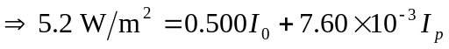 (2).
Solving equations (1) and (2) we find:
Then if one subs this back into equation (1), we find:
5.049 = 